Merton Young Saver
Parent/Carer Guide


Click on the link to apply: Merton Young Savers (croydonplus.co.uk)
Scroll down the click on “Join Now”
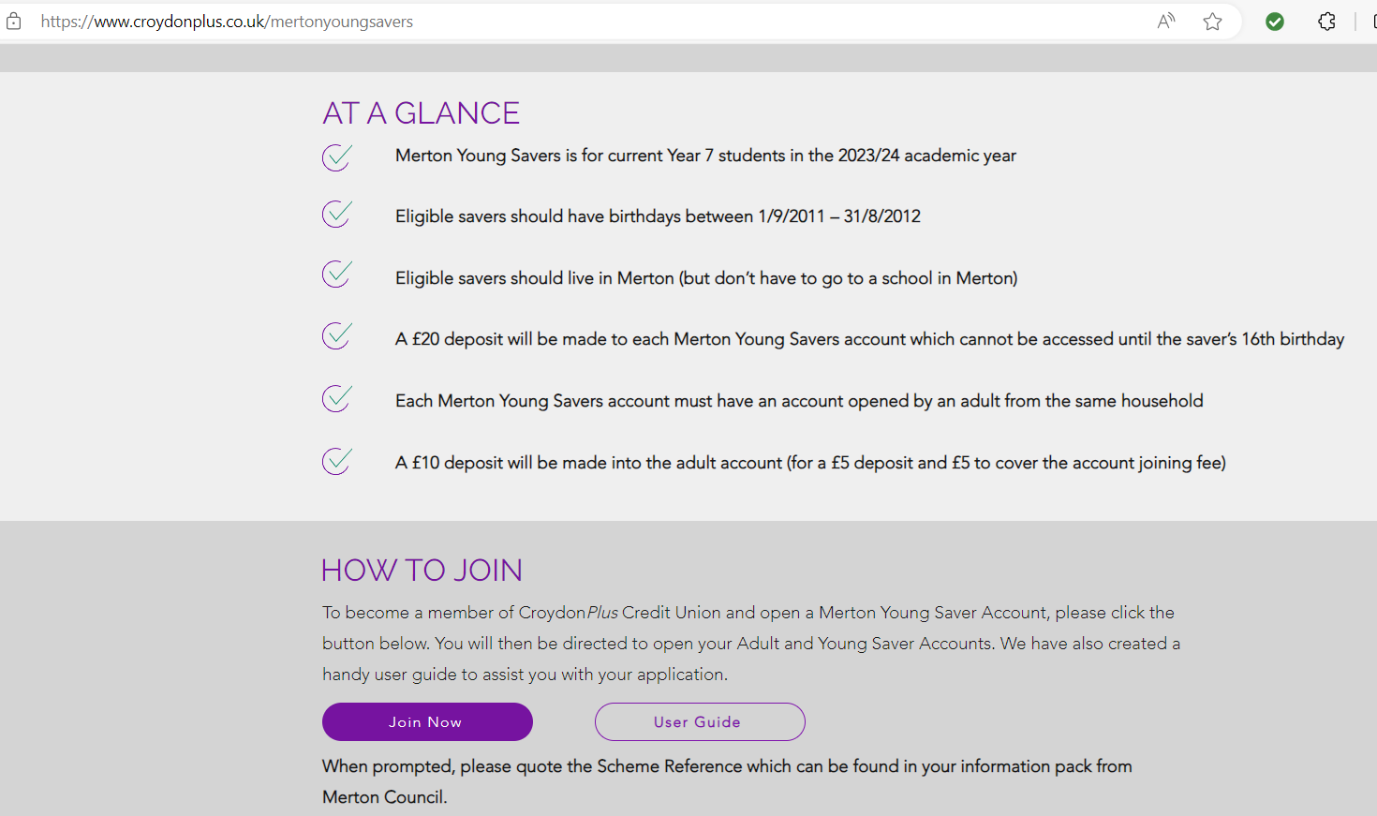

Please note that we will require documentation to complete the application and to take advantage of the free deposit. (See bottom of the Parent/Carer Guide)



How to apply for Merton Young Savers
Step by step guide to help you register for a Merton Young Savers account.
- Open the link provided, and in the first option box; I live, work or study in the following area Please select – Merton
- Do you wish to open young savers account for your child? Select – Yes
- Please write your Unique Code given to you by your school HERE
(Can be found in attached file – Leader letter, in the original email from Merton Council)
- Please select your child’s school (if the school is not listed, select other and manually input an appropriate response)
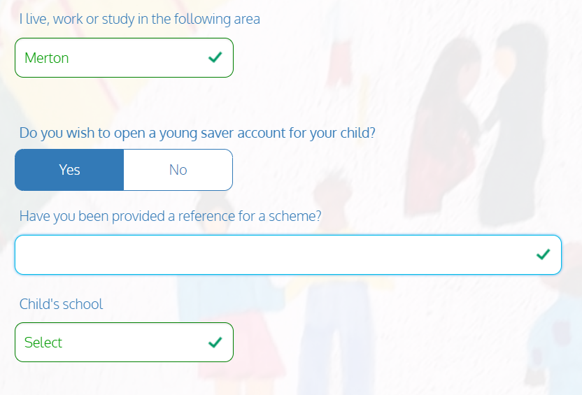
- Please fill out your child details – First name, Middle name (optional), Last name, DOB (Date of Birth)
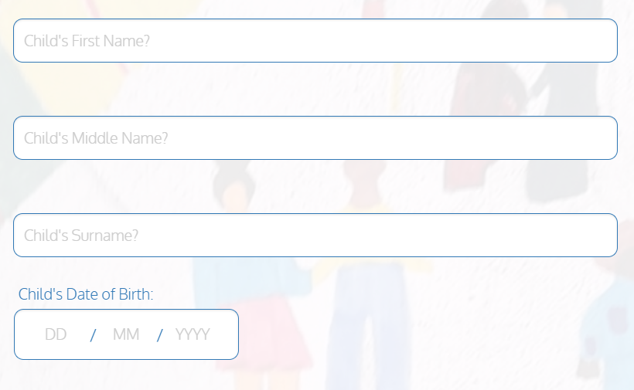
- Please fill in your (parents) details – Title, First name, Middle name, Last name, DOB (Date of Birth), NI (National Insurance) Number, Residential Status, Current address and how long you have lived at your current address.

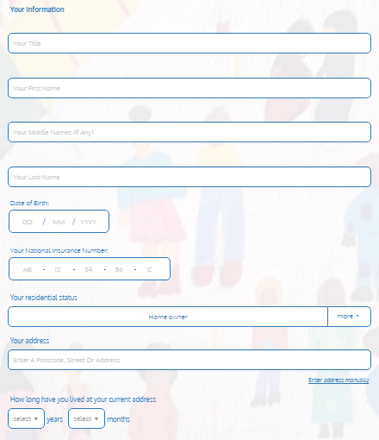
- Please fill in your Home Telephone Number, Mobile Telephone Number and Email Address; and how you heard about Croydon Plus Credit Union.

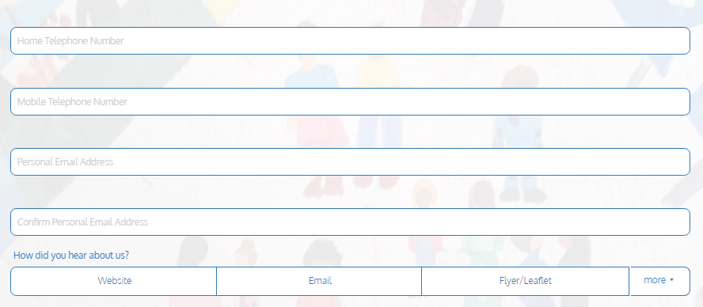
- Please provide your bank account details for ID verification and payments for any future funds that the credit union sends to you. (Bank sort code and account number)

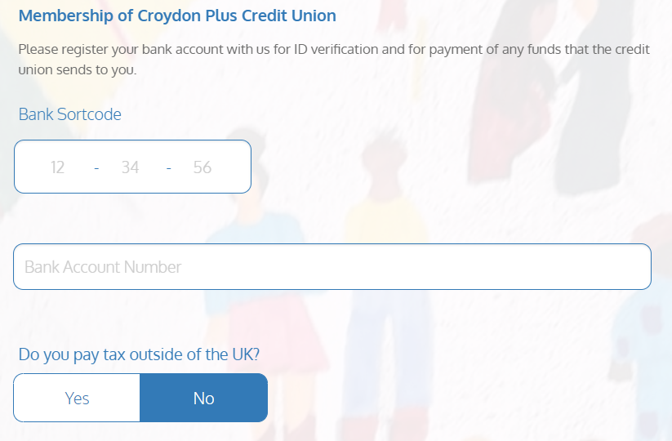

- Please confirm whether you pay tax outside the UK, and provide beneficiary details, (FOR ADULT MEMBER ONLY) please note, these can be provided at a later date.
(Note. Credit unions collect beneficiary details to ensure that, in the unfortunate event of a member's passing, their financial assets are transferred seamlessly and efficiently to their chosen loved ones or heirs. Some exceptions may apply)

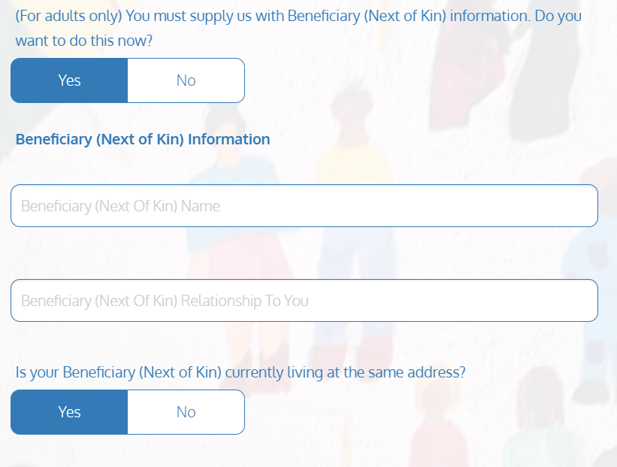
- Please SELECT your employment status.

If employed (full-time/part-time/self-employed) please provide the following details, Occupation, Employers Name and Employer’s Address. (*payroll number is optional)
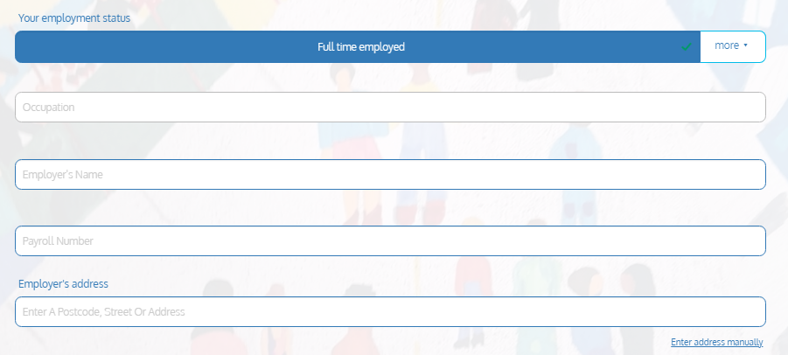
For ALL other options – Select appropriate option and press Next
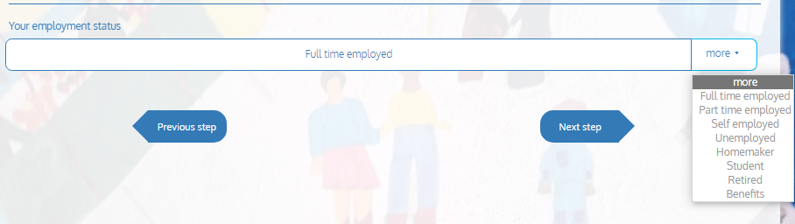

- Lastly, review your details and confirm you agree with the terms and conditions, and press SUBMIT
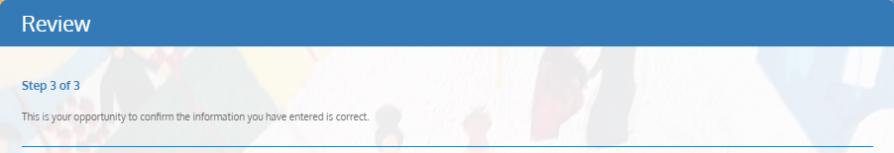
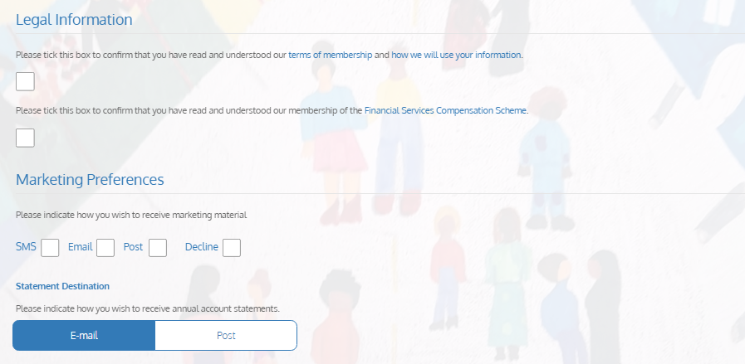
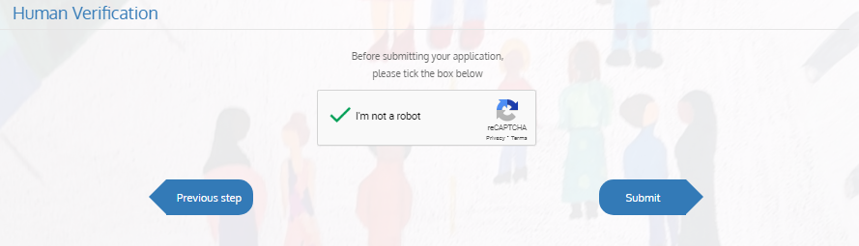

What next

Once your application is submitted you will receive an email shortly afterwards advising you of your membership numbers (One for the adult and one for the Young Saver account). We will also attempt to contact you as soon as possible and provide you with a welcome letter/email.

To complete your account opening, you will need to provide the birth certificate for the Merton Young Saver’s account holder (student), your photo ID (parent/guardian) and proof of address (parent/guardian) to us via the secure email provided: mys@croydonplus.co.uk.

Please accept our apologies in advance if you experience any delays in receiving your welcome letter/email due to the high demand of this new savings scheme.

Should you have any questions in the meantime please do not hesitate to contact us on 0203 468 8568 or via secure email at mys@croydonplus.co.uk

We welcome you to Croydon, Merton & Sutton Credit Union!

